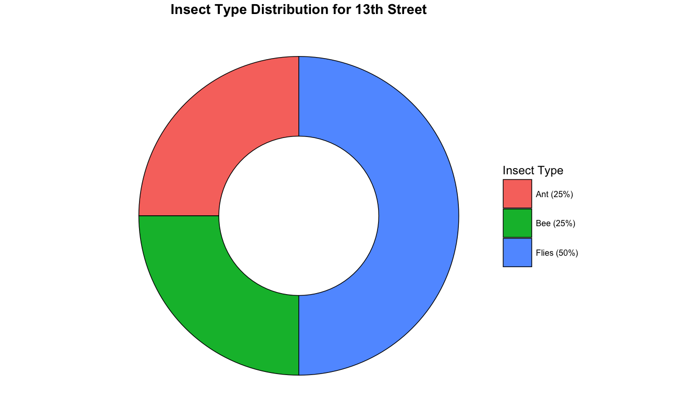
Half of the insects collected at your orchard were flies! Flies are particularly important pollinators in the spring, because they are more active when it is cool and overcast compared to bees. The abundance of flies also suggests there may be decaying material nearby (such as dumptsers or cashes of wild cats). The most common groups of bees in your orchard are...Interestingly, no honey bees were collected at your orchard! Relatively low bee diversity may hinder effective pollination for fruit trees, but we are still testing that. The ants, although not primary pollinators, are probably collecting nectar, because they do not feed their young pollen like bees do. Once all species have been identified, we will send you a complete list of the insects in your orchards!

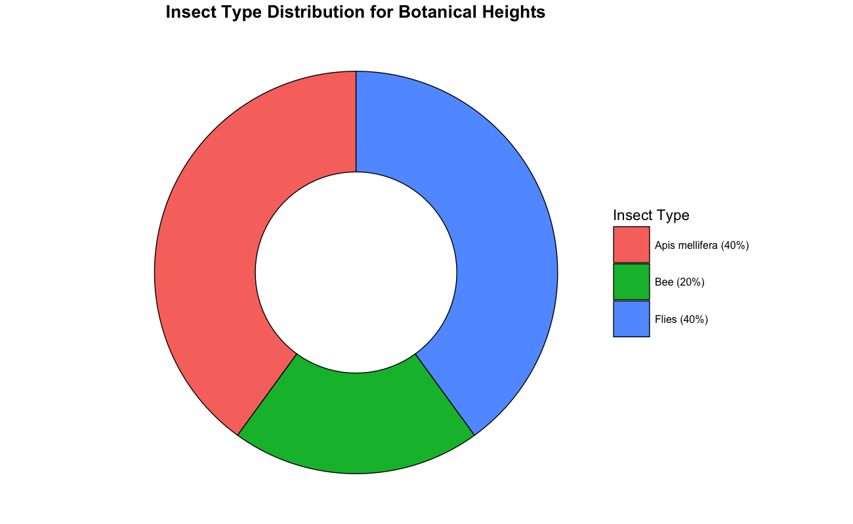
At your site, 40% insects that were collected are honey bees and flies. Flies are particularly important pollinators in the spring, because they are more active when it is cool and overcast compared to bees. The abundance of flies also suggests there may be decaying material nearby (such as dumpsters or cashes of wild cats). The large percentage of honey bees is a good sign as they move pollen from one flower to another while collecting nectar. This helps plants make fruits, seeds, and new other plants. Also, the other 20% says bee which are primarily mining bee (andrena) and mason bee (osmia). As the name suggest, mining bee digs small tunnels in the ground to make their nest and mason bees use mud/clay to build their nest in little holes. Once all species have been identified, we will send you a complete list of the insects in your orchards!

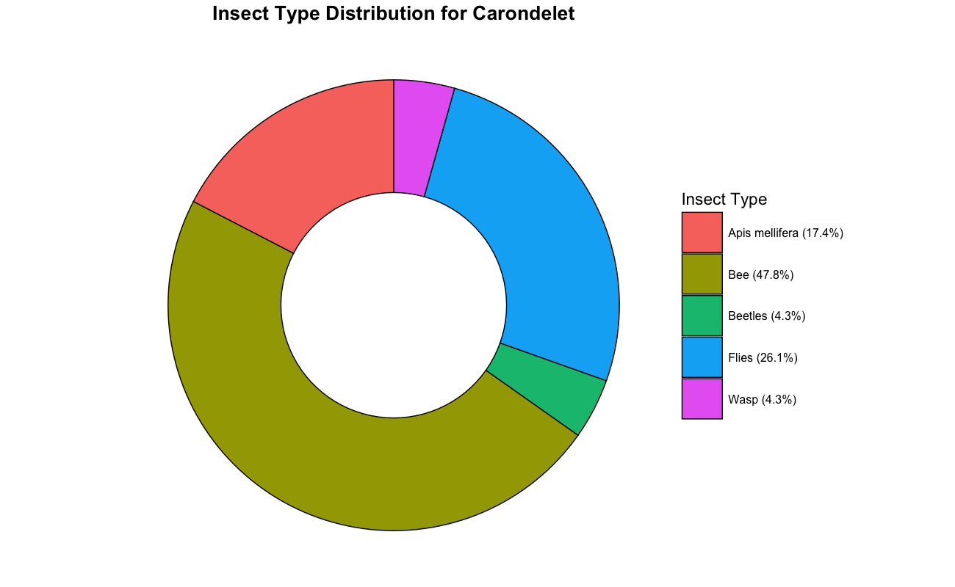

More than half of the insects collected at your site are bees, 17.4% being honey bee (apis mellifera), 47.8% bee (43.5% mining bee (andrena)), and flies total to 26.1%. Flies are particularly important pollinators in the spring, because they are more active when it is cool and overcast compared to bees. This also suggests there may be decaying material nearby (such as dumpsters or cashes of wild cats). The majority of bee are mining bee which digs small tunnels in the ground to make their nest. This is a good sign as mining bee alongside honey bees moves pollen from one flower to another while collecting nectar. This helps plants make fruits, seeds, and new other plants. Once all species have been identified, we will send you a complete list of the insects in your orchards!

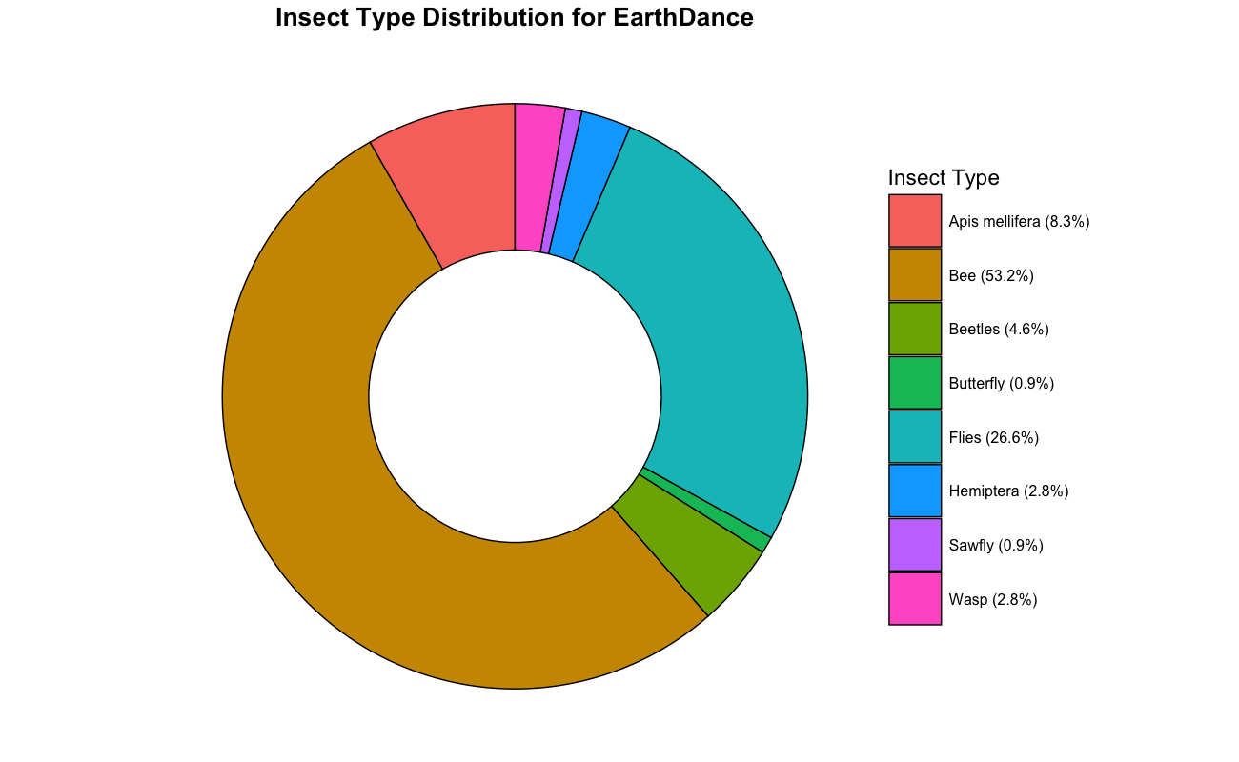
More than half of the insects collected at your site are bees, 8.3% being honey bee (apis mellifera), 53.2% bee (44% mining bee (andrena)), and flies total to 26.6%. Flies are particularly important pollinators in the spring, because they are more active when it is cool and overcast compared to bees. This also suggests there may be decaying material nearby (such as dumpsters or cashes of wild cats). The majority of bee are mining bee which digs small tunnels in the ground to make their nest. This is a good sign as mining bee alongside honey bees moves pollen from one flower to another while collecting nectar. This helps plants make fruits, seeds, and new other plants. Once all species have been identified, we will send you a complete list of the insects in your orchards!

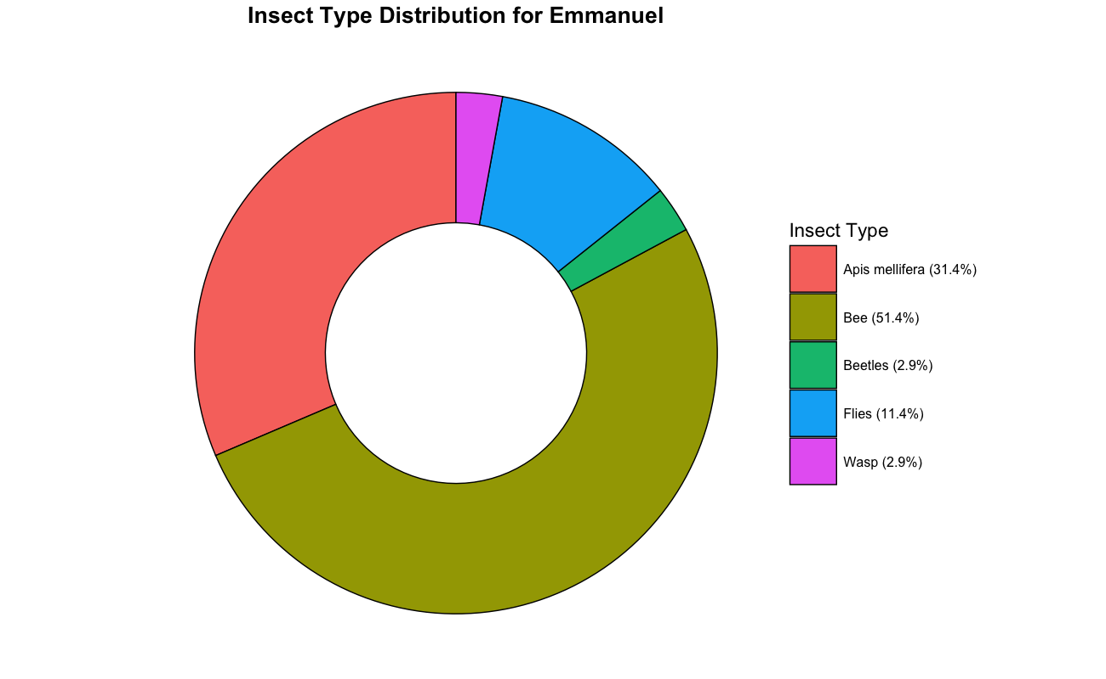
More than half of the insects collected at your site are bees, 31.4% being honey bee (apis mellifera), 51.4% bee (51.4% mining bee (andrena)), and flies total to 11.4%. Interestingly all the bees were honey bee and mining bee. This is a good sign as honey bees move pollen from one flower to another while collecting nectar. One thing to be noted, mining bee digs small tunnels in the ground to make their nest. So, when mining and honey bee visits flowers, they carry pollen and help plants grow fruit and seeds.

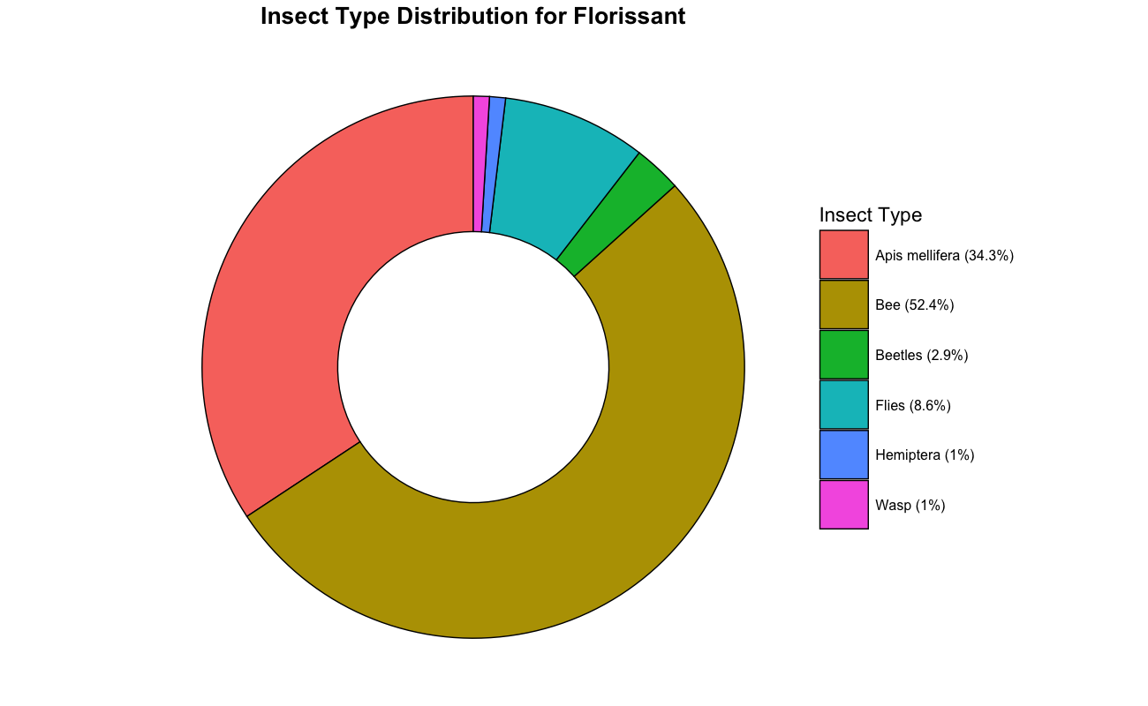
More than half of the insects collected at your site are bees, 34.3% being honey bee (Apis mellifera), 52.4% bee (44.8% mining bee (Andrena)). Mining bee digs small tunnels in the ground to make their nests and can be excellent pollinators of orchard trees. Flies are the next most abundant pollinator group, which is great because they will fly when it is cool and wet. Bees tend to be more active when it is warm, sunny and dry. This diversity may help to maintain pollination despite variable weather conditions.
Usda biml flickr

THINGS CAN BE CHANGED

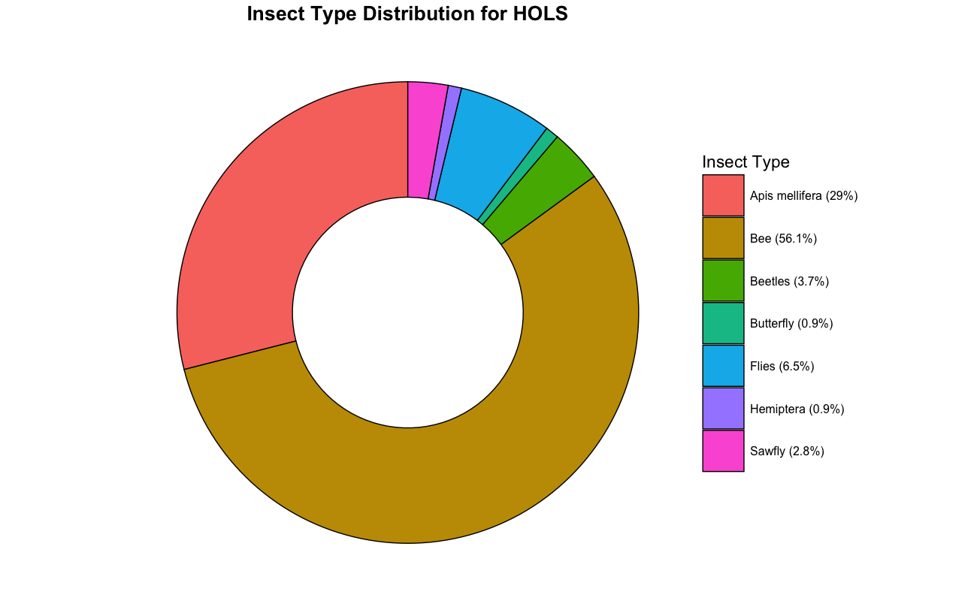
Nearly 70% of the insects collected at your site were bees, showing that this orchard is strongly supported by bee pollination. The two most common groups were ming bee (38.3% andrena) and honey bee (29% apis mellifera), which together made up more than two-thirds of all insects observed. Other wild bees were present in smaller numbers but together add to the diversity of pollinators. In addition to bees, a few flies were recorded. Flies are especially important early in the spring when bees are less active in cool or cloudy weather.

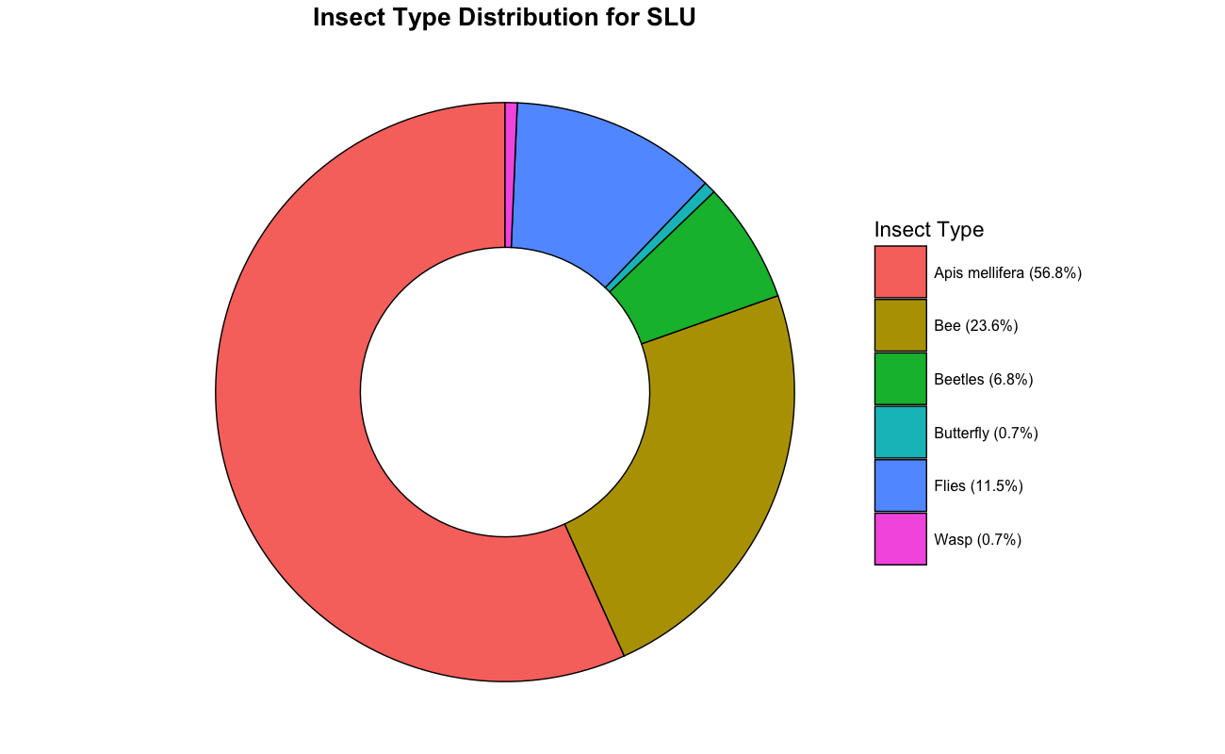
Nearly 80% of the insects collected at your site were bees, showing that this orchard is strongly supported by bee pollination. The two most common groups were ming bee (17.6% andrena) and honey bee (56.8% apis mellifera), which together made up more than two-thirds of all insects observed. This is a good sign as mining bee alongside honey bees moves pollen from one flower to another while collecting nectar. This helps plants make fruits, seeds, and new other plants. Other wild bees were present in smaller numbers but together add to the diversity of pollinators. In addition to bees, a few flies were recorded. Flies are especially important early in the spring when bees are less active in cool or cloudy weather.

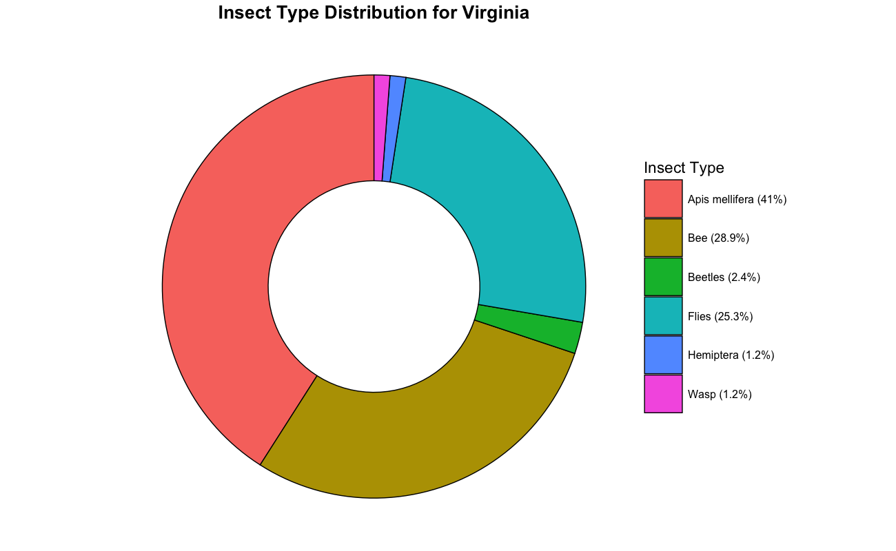

More than half of the insects collected at your site are bees, 41 % being honey bee (apis mellifera), 28.9% bee (13.3% mining bee (andrena), 4.8% mason bee (osmia)), and flies total to 25.3%. Flies are particularly important pollinators in the spring, because they are more active when it is cool and overcast compared to bees. This also suggests there may be decaying material nearby (such as dumpsters or cashes of wild cats). Most bees are honey bees, which is a great sign! They work with other bee species, like mining and mason bees, to move pollen from one flower to another while collecting nectar. This helps plants make fruits, seeds, and new other plants.

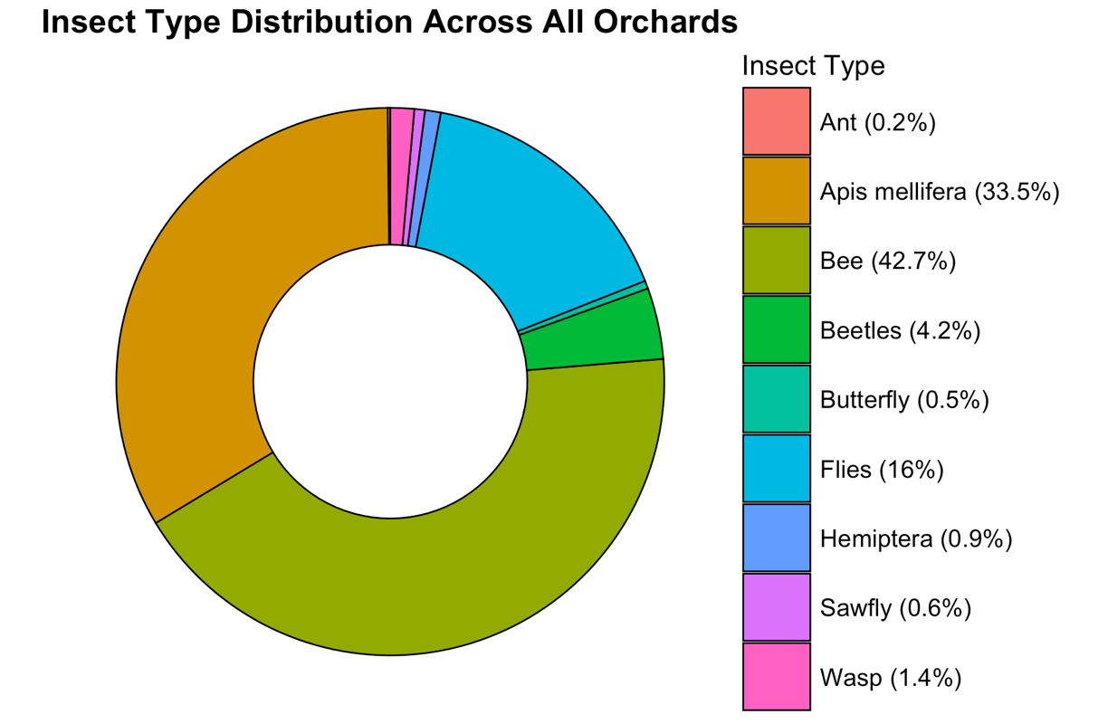

Bees were the most common insects found in the orchards, making up 42.7% of the total. Honey bees (Apis mellifera) were the second most common, accounting for 33.5%. Together, these two groups are the main pollinators in the system. Flies made up 16% of the observations, which is important because they’re still active in cool, overcast weather when bees aren’t as effective. Their presence might also indicate nearby decaying organic matter. Beetles (4.2%), wasps (1.4%), hemipterans (0.9%), sawflies (0.6%), butterflies (0.5%), and ants (0.2%) were also found, but in smaller numbers. Despite their smaller numbers, these other insect groups still contribute to the diversity of flower visitors. Overall, the insect community in the orchards is dominated by bees and flies, with other insect groups playing smaller but important roles in pollination.
The diversity of insects in your orchards is super important because it affects how well they’re pollinated. This, in turn, impacts how many fruits grow and how much you get. Bees and honey bees are the best pollinators, so having them around is a great sign for your crops. But guess what? Flies also help out by pollinating when bees are taking a break, like during cool, cloudy, or early spring. This way, you get consistent pollination throughout the season. Even if one group of insects isn’t as active because of weather, disease, or changes in their habitat, others can keep things going. So, the more diverse and abundant these insect visitors are, the stronger your orchards become and the more reliable they are for producing fruit.
In the spring of 2022, 2023, and 2024, researchers used camcorders to record insect behavior in 10 orchards. They chose trees randomly and focused on small areas of flowers, with about two flowers per patch. Each recording lasted between an hour and two hours. This method allowed them to make consistent observations of insects visiting flowers in real-world orchard settings.

Most of the insects that visit the orchards are active during the day, but their peak activity depends on the group and the weather. Bees, including honey bees, are usually most active on warm, sunny days when flowers are producing the most nectar and pollen. Flies, on the other hand, are often active earlier in the morning and under cooler, cloudier, or even slightly rainy conditions when bees are less active, making them especially important in spring. Other groups, like beetles and wasps, tend to be active during the warmer parts of the day, while butterflies usually prefer sunny, calm conditions.

